Test # 246
Instrument Name Consistometer
Instrument Type Consistometer
Test Start 28/03/01 10:36
Test Stop 5:39:36
Well ID # test1 (remix)
Customer KOGALYM
Cement Class G
Additives 1.4%TDF-1+Defoamer
Cement Mfr DYKERHOFF
BHCT 40
BHST 70
Density 1900
Fluid Loss
Job Type 146 MM CSG
Comments MPa: 38.3 (31min); T: 40C (31min)
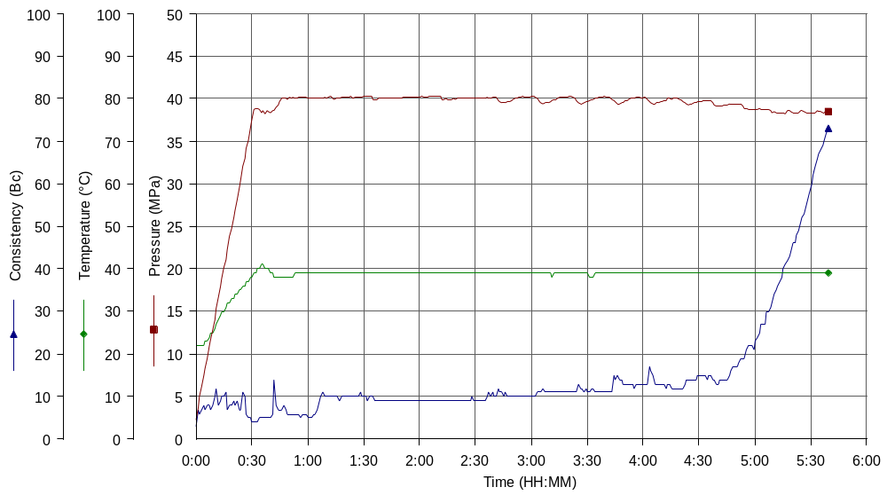
Kogalym water & cement, premix; based on Test#127

